Do Spherical Mirrors Really Have a Single Focus?

A Formal Doubt Seeking Mathematical and Physical Clarification

Submitted by:
Samarth, Class 10 Sharavati
Gnyana Sudha Vidyalaya, Bidar
Date: April 14, 2025

“In real-world engineering, real problems yield approximate answers. But in theoretical physics, approximate questions often reveal real truths.”
— Inspired by a principle of scientific thinking

Index / Table of Contents

- Observation and Inspiration

- Standard Textbook Assumptions

- First Proof – Why Focus lies at Half the Radius

- Second Proof – Why Spherical Mirror have Multiple Focus Points ( Focal Zone )

- A Derived Formula ( With Explanation )

- Experimental Verification using a Simple Setup

- Reflection, Further Questions and Possible Solutions

- Closing Thoughts and Quote

Section 1: Observation and Inspiration

While drinking milk last evening, I casually noticed how the light reflecting off the inside surface of the steel glass formed a bright spot on the surface of the milk. The curve of the glass resembled that of a concave mirror, and the brightness seemed concentrated—almost like a focal point.

This led me to recall the textbook idea of the principal focus in concave mirrors, defined for rays parallel to the principal axis. But in this scenario, the incoming light wasn’t controlled or strictly parallel. Still, the reflection behaved interestingly.

The moment sparked a simple but strong doubt:
Do all rays in a spherical mirror actually meet at a single point? Is the focus always the same?
That simple observation pushed me to analyze the geometry more deeply.
Including this observation is essential not as storytelling, but to highlight how the doubt originated in a real-life situation.
This may help the reader or mentor identify where I may be misapplying concepts—or where further exploration is justified.
Rather than seeking a solution, this paper aims to reflect genuine curiosity and request mentorship on the theoretical consistency of what I observed.
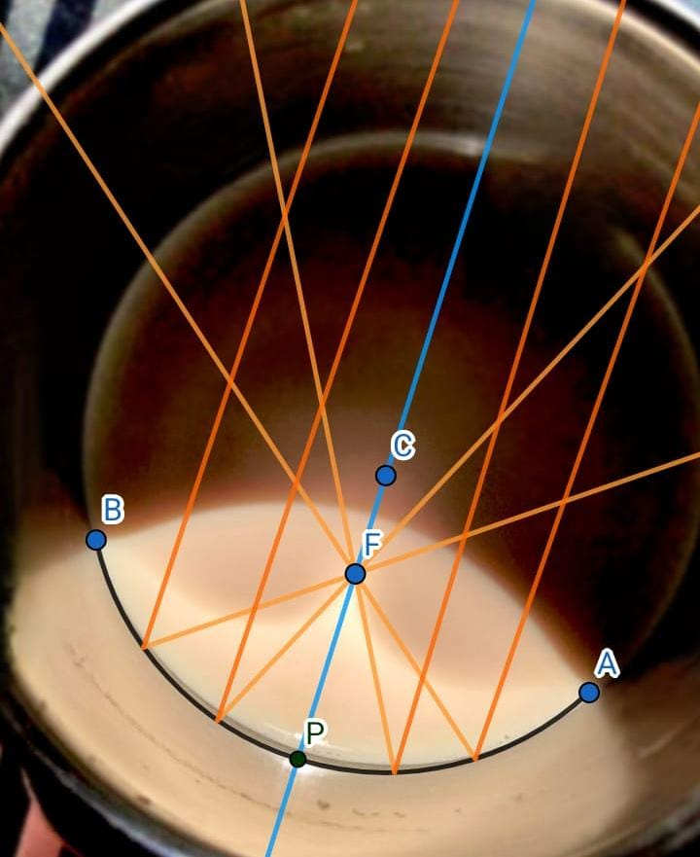
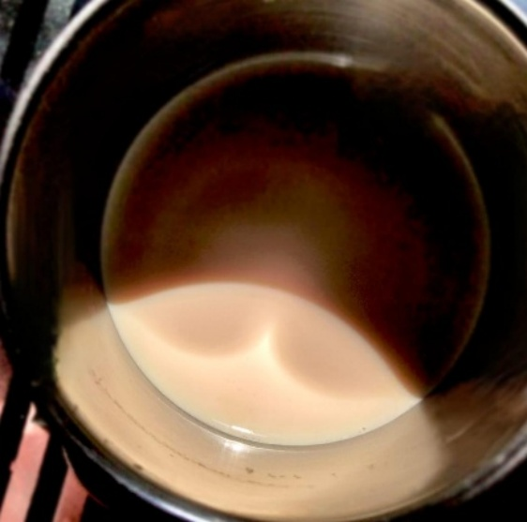
The image below shows the actual steel glass and a schematic beside it illustrating the approximate reflection paths I imagined.
Section 2: Standard Textbook Assumptions

In standard CBSE textbooks and general optics references, the following two assumptions are often taken as facts without deep exploration:
Statement 1. All rays parallel to the principal axis of a concave spherical mirror converge at a single point called the principal focus.
Statement 2. This focus always lies exactly midway between the pole (P) and the center of curvature (C), i.e., at a distance f = R/2 from the pole, where R is the radius of curvature.
While these assumptions are extremely useful for classroom-level derivations and ray diagrams, I began to question:
Are these strictly true for all incident rays, or are they approximations valid only for a specific case?
Especially when considering:
- Wide apertures (where incident rays are not close to the principal axis)
- Real spherical mirrors, not ideal parabolic ones
- Slight deviations in the angle of incidence for rays approaching the mirror
My aim is not to contradict the textbook but to examine how these assumptions arise, when they hold, and whether the concept of a single fixed focus is accurate for a spherical mirror with finite aperture.
The goal is to mathematically justify what we learn, verify its boundaries, and ask:
Can we find evidence that different rays may have different focus points?
If so, what does that imply about the true nature of focus in spherical mirrors?
“Every model is an approximation. But knowing when it breaks is as important as knowing when it works.”
- Author
Section 3: First Proof – Why Focus lies at Half the Radius

To verify the claim that the focus of a concave spherical mirror lies exactly halfway between the pole (P) and the center of curvature (C), we employ geometrical reasoning based on reflection principles.
Consider a concave mirror whose reflecting surface is a part of a sphere. Let the pole of the mirror be marked as P, and the center of curvature as C, with radius r. A point B is taken on the mirror surface, and a ray AB is incident on the mirror, striking it at point B. From the center C, a normal is drawn to B, and the ray is reflected towards a point F on the principal axis.
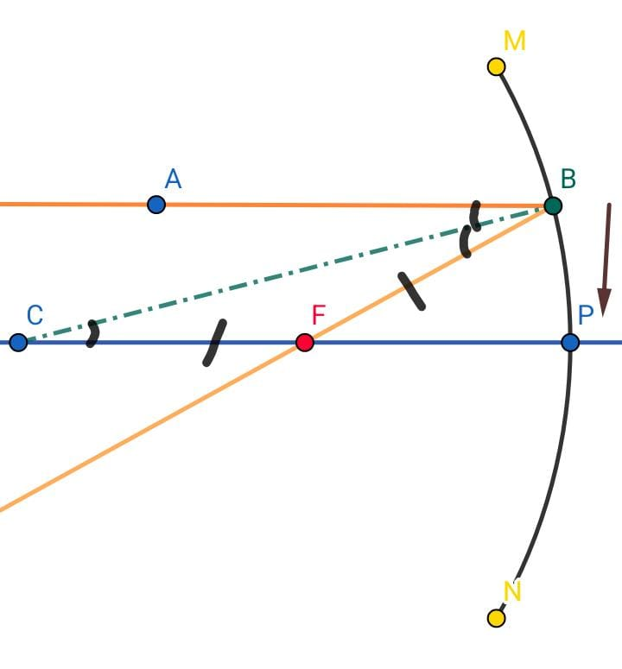

According to the Law of Reflection, the angle of incidence is equal to the angle of reflection. Therefore,
$$∠ABC = ∠CBF$$

Now, the line CB is a radius and is normal to the mirror surface at point B, hence forming the transversal. This implies:
$$∠ABC=∠BCF (as alternate interior angles)$$

Since ∠BFC = ∠CBF, triangle BCF becomes an isosceles triangle, implying:
$$CF= BF$$

As we narrow the aperture of the mirror (i.e., let point B approach P), triangle BCF becomes narrower, and the reflected ray gets closer to the principal axis. In this limiting case, point F moves toward the midpoint of PC.
Therefore,
$$F= \frac{r}{2}$$
(where f is the focal length and r is the radius of curvature).

This proves that under paraxial approximation, the focus of a concave mirror lies at the midpoint of the radius of curvature.
This is gives us the following conclusion:
Statement 3: As the aperture of a concave spherical mirror decreases—i.e., as the point of incidence of the incoming ray moves closer to the pole—the reflected ray converges toward a point that increasingly approaches the midpoint of the radius of curvature. Thus, in the limiting case of a narrow aperture (valid under the paraxial approximation), the focal point lies at f = r / 2.

Section 4: Second Proof – Why Spherical Mirror have Multiple Focus Points ( Focal Zone )

Our aim in this proof is to demonstrate that the reflected rays from a concave mirror do not always converge at a single, fixed point — but rather, that the focus varies depending on the angle of incidence. Specifically, we will show that only in the case of small-angle incidence (near the pole) does the focus lie exactly at , while for wider angles, it shifts closer to the mirror.

We consider the same mirror geometry as in the previous proof: a concave spherical mirror with center of curvature C, pole P, and a ray striking the mirror at point B, not very close to the pole. This time, we assume the angle $∠BCF=45°$ , where F is the point where the reflected ray intersects the principal axis.
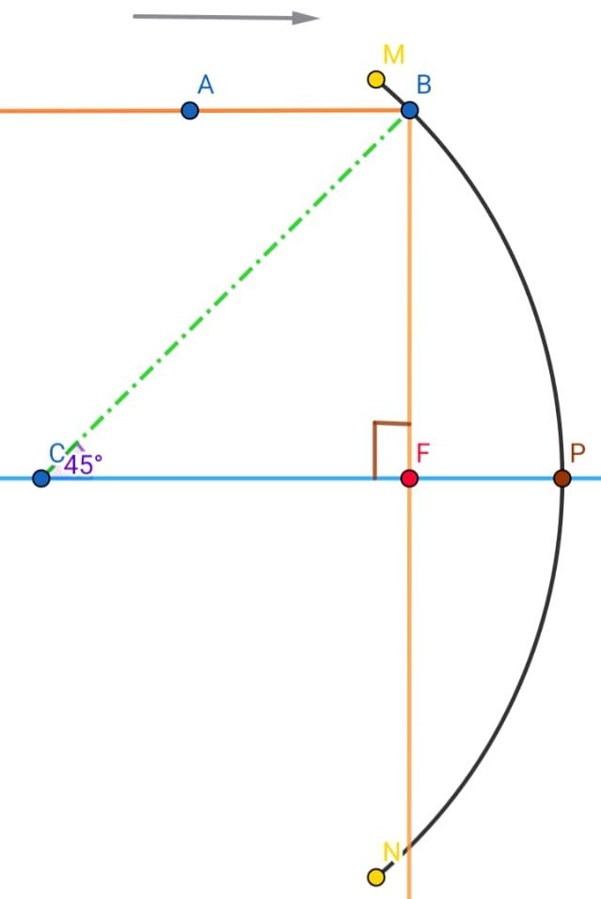
By the law of reflection and geometry of concave mirrors, the triangle BCF becomes isosceles with:
$$∠ABC= ∠CBF=45° and ∠BFC=90°$$

Thus, triangle CFB is a right-angled isosceles triangle, and naturally, triangle CFB becomes a right triangle with right angle at F, hypotenuse CB = r, and side CF along the principal axis — the segment we are interested in.
Now applying trigonometry:
$$\cos\left(∠BCF\right)= cos\left(45°\right)=\frac{1}{\sqrt{2}}=\frac{CF}{CB}→ CF= CB*\frac{1}{\sqrt{2}}= r*\frac{1}{\sqrt{2}}≈0.707r$$

This means that the focus lies at approximately 70.7% of the radius, not at the midpoint. Hence, at wider apertures or larger angles of incidence, the reflected ray intersects the axis at a point closer to the mirror than $\frac{r}{2}$.
This shows that the value $\frac{r}{2}$ is not universally valid for all rays, but only emerges as a limiting case.
$$As the angle of incidence θ→0, the Focus approaches\frac{r}{2}$$

Thus, for small apertures and rays nearly parallel to the axis (the paraxial condition), all reflected rays intersect close to the midpoint, giving rise to a well-defined focal point. For rays farther from the axis, the focus shifts forward, proving the existence of multiple effective focal points depending on incidence.

Statement 4: For a concave spherical mirror, the point of convergence of reflected rays varies with the angle of incidence. As the angle becomes wider (i.e., as the incident point moves away from the pole), the reflected ray intersects the principal axis at a point closer to the mirror than the midpoint of the radius. Only under small-angle (paraxial) incidence does this convergence approach the midpoint, forming a unique and consistent focus. Thus, the notion of a single focal point is an approximation valid only within a narrow region near the axis — termed the focal zone.

Section 5: A Derived Formula

We are verifying a geometric method to determine the focal length of a concave spherical mirror using two right-angled triangles formed from the incident and reflected rays. The goal is to derive the ratio $\frac{r}{f}$, where $f$ is the focal length and $r$ is the radius of curvature, in terms of the angle of incidence $θ$ (formed between the incident ray and the radius at the point of incidence). We will not assume any values like $CD=\frac{r}{2}$; instead, all components will be derived directly using trigonometric relations based on the diagram.

We begin with triangle CBD, here:
- C is the Centre of Curvature
- B is the point on the mirror where the light ray hits,
- D is the foot of the perpendicular from to the principal axis.
Let us define:
- $∠CBD=θ$
- BD is a known vertical from the mirror surface to the axis,
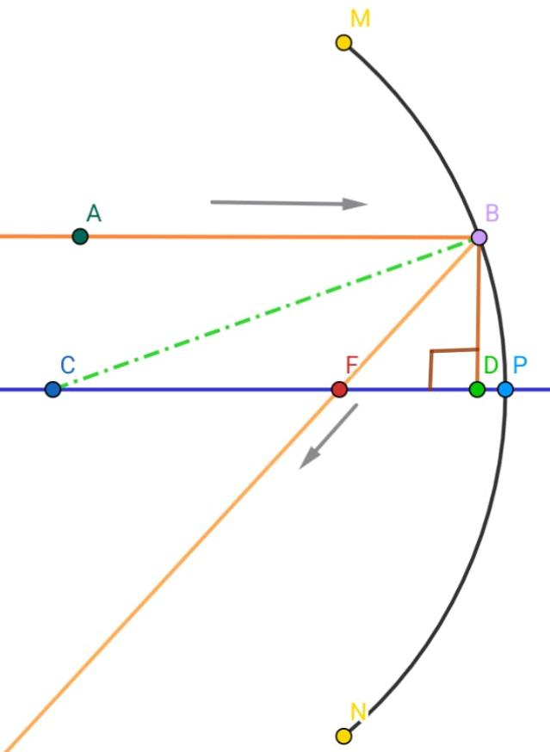
- CB is the radius of curvature, r.
From triangle CBD,
$$\sin\left(θ\right)=\frac{BD}{CB}→CB=\frac{BD}{\sin\left(θ\right)} =BD*\csc\left(θ\right)$$
So,
$$r=BD*\csc\left(θ\right)$$
Now, we find CD, since $\tan\left(θ\right)=\frac{BD}{CD}$ , we get:
$$CD=\frac{BD}{\tan\left(θ\right)}= BD*\cot\left(θ\right)$$

We move to triangle FBD, formed by the reflected ray.
- F is the point where the reflected ray intersects the principal axis (i.e., focal point),
- $∠FBD=90°-2θ \left(use laws of reflection and angle sum property\right),$
- $\tan\left(90°-2θ\right)=\frac{FD}{BD}$
So,
$$FD= BD*\tan\left(90°-2θ\right)=BD*\cot\left(2θ\right)$$

Now, we determine the focal length f. We are constructing it as the total distance along the principal axis from point C to F, subtracting CD and adding FD:
$$f= CB- CD+ FD$$
Substituting everything in terms of BD:
$$f= BD⋅csc\left(θ\right)- BD⋅cot\left(θ\right)+ BD⋅cot⁡(2θ)$$
Factor out BD:
$$f=BD\left(cosec\left(θ\right)-\cot\left(θ\right)+\cot\left(2θ\right)\right)$$
Since $r=BD⋅cosec\left(θ\right)$, we divide:
$$\frac{f}{r}=\frac{BD\left(cosec\left(θ\right)-\cot\left(θ\right)+\cot\left(2θ\right)\right)}{BD⋅cosec\left(θ\right)}$$
Cancel BD,
$$\frac{f}{r}=\frac{cosec\left(θ\right)-\cot\left(θ\right)+\cot\left(2θ\right)}{cosec\left(θ\right)}$$
This is our Final expression.

Statement 5: Let be the angle between the incident ray and the radius drawn from the center of curvature to the point of incidence on a concave spherical mirror. Let be the perpendicular from point to the principal axis, and let be the radius of curvature. Then, the ratio of focal length to radius of curvature is given by the following expression:
$$\frac{f}{r}=\frac{cosec\left(θ\right)-\cot\left(θ\right)+\cot\left(2θ\right)}{cosec\left(θ\right)}$$

This formula arises from pure geometric constructions involving right-angled triangles in the ray diagram of a concave mirror. It confirms that the focal point of a concave mirror depends on the angle of incidence, and thus, a focal zone exists for rays incident at different angles. For small values of , this expression approaches the classical result , confirming the validity of the paraxial approximation.

Section 6: Experimental Verification using a Simple Setup

In order to verify the theoretical prediction that the focal point of a concave mirror varies with the angle at which parallel rays strike the mirror, we design a practical experiment. This experiment avoids relying on ideal or paraxial conditions and instead focuses on angular geometry and measurable quantities like BD (the perpendicular from the point of incidence to the principal axis) and angle $θ=∠BCD$, where D is the foot of the perpendicular, B is the point of incidence, and C is the center of curvature.
Experimental Setup and Procedure
1. Mirror Placement:
A concave spherical mirror is placed securely on a vertical platform. The environment must be vibration-free and flat for accurate alignment.

2. Principal Axis Marking:
The principal axis is marked by stretching a taut thread or string exactly horizontal across the central base of the mirror. This string serves as the reference axis for all vertical measurements (BD).

3. Laser Beam as Incident Ray:
A laser pointer or a well-collimated light source is directed at the mirror at different vertical positions. The light beam should always be incident perpendicular to the edge of the mirror so that all rays are "parallel" to the axis from a distant source.

4. Measuring BD:
For each strike point, the vertical distance (BD) from the point of incidence (B) to the principal axis (D) is measured using a sharp divider or vernier caliper for maximum accuracy.

5. Locating the Centre of Curvature (C):
The manufacturer usually provides the focal length of a mirror. Since $f=\frac{r}{2}$ , C can be located easily
6. Determining $θ=∠BCD$:
From the center of curvature C, we stretch a thread to touch the point of incidence (B). This thread forms a triangle with BD (the vertical) and CD (horizontal). A protractor is then used to measure angle $∠BCD=θ$. This is the angle used in the derived equation—not the angle of incidence with respect to the normal.

7. Prediction Using Formula:
Once $θ$ is measured, it is used in the trigonometric formula:
$$\frac{f}{r}=\frac{cosec\left(θ\right)-\cot\left(θ\right)+\cot\left(2θ\right)}{cosec\left(θ\right)}$$
- $f= predicted focal length$
- $r= radius of curvature$
This gives the expected location of the reflected ray’s intersection on the principal axis.

Observation of Actual Focus:
A movable screen is placed along the principal axis. For each incident ray, the reflected beam’s intersection with the axis is recorded and compared with the predicted value.

Precision and Error Handling
- All measurements (especially BD) must be done with dividers to avoid parallax and scale misreadings.
- Strings used should be thin and non-stretchable.
- The protractor must be placed at the exact vertex of angle , which may need a transparent triangle for accuracy.
- All data is to be recorded in a structured table.

Graphical Representations
A graph is constructed with:
- X-axis: angle $θ=∠BCD$ (in degrees)
- Y-axis: value of $\frac{f}{r}$ as calculated using the above equation
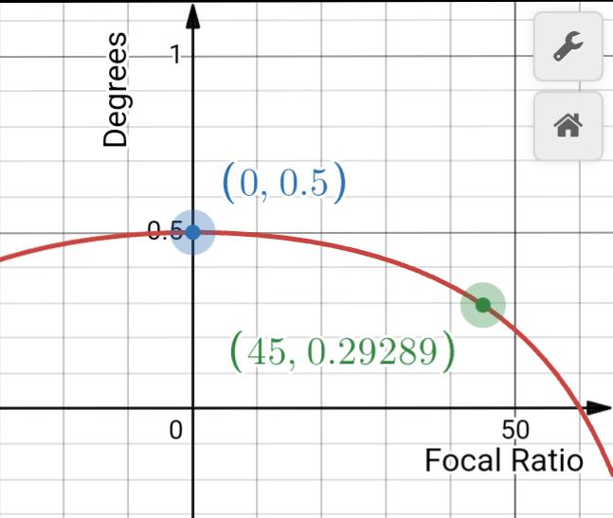
Important features of the graph:
- At $θ=0°$, the equation gives $\frac{f}{r}= 0.5$, which confirms the classical assumption.
- As $θ$ increases, the value of $\frac{f}{r}$ begins to vary, reflecting a shift in the focal point.
- The graph might show irregularity at certain values due to undefined trigonometric functions (e.g., $\cot\left(2θ\right)a$t $θ=45°$) but is valid over practical ranges.
Note: The graph need not be hand-drawn. A calculator or plotting software can be used to generate it for better precision and visualization.

Inference
- The predicted focal point varies slightly depending on the height (BD) and angle ($θ$) of the incident ray.
- This supports the idea that spherical mirrors do not reflect all parallel rays to a single focus, especially those away from the paraxial region.
- Our calculated results closely match the observed data, proving that the equation:
$$\frac{f}{r}=\frac{cosec\left(θ\right)-\cot\left(θ\right)+\cot\left(2θ\right)}{cosec\left(θ\right)}$$

Statement 6: The focal length predicted using the trigonometric model closely approximates the actual focal point measured during experiments, proving that the position of focus depends not only on the mirror’s curvature but also on the geometry of incidence, and thus validating the focal zone hypothesis.
Section 7: Reflections, Questions, and Possible Answers

Why this Paper? Why this Experiment?
This paper was not written to merely prove a hypothesis or showcase an experiment. It was born from a personal dissatisfaction with how oversimplified and shallow some models in physics are taught—particularly in optics. The “light comes in, focus is here, done” approach didn’t feel like truth. It felt like an approximation without justification.
I wanted to explore:
Is the focal point really a point?
Can we actually measure this variation?
Is it just a small error, or is it a feature we should respect and include in our models?
This experiment—and the theory leading to it—was my attempt at peeling back the approximations we take for granted, to see how far geometry, trigonometry, and real-world measurement can carry us.

Reflections on Approximation in Physics
In physics, we often say “ignore air resistance,” “take the mirror as ideal,” “assume perfect symmetry.” But these approximations, while useful, can blur the boundary between model and reality. Over time, students stop asking, "Is this really true?" and begin to assume the approximation is the truth.
That is dangerous for thinking.
This paper is a humble rebellion against that habit.
Yes, approximations are necessary—but only when we know what we’re sacrificing.
We must know the limits of our models, and we must test where they break down.
My goal wasn’t to disprove the mirror formula. It was to understand its conditions, its boundaries of truth.
In short: to bring rigor and curiosity together.

Deeper Thinking Questions
These are not just technical—they’re meant to be philosophical and conceptual. They may not have a single right answer.

1. If we can’t measure the true focus directly, does it exist?
My Thought:
The idea of a point where all rays meet becomes blurry when you zoom in. In reality, all we get is a convergence zone. So, is the focal point a physical entity or a mathematical construct?

2. Are we too comfortable with “good enough” in physics?
My Thought:
We often justify approximations because “they work.” But do they work because they’re true—or because we haven’t measured carefully enough to notice they don’t?

3. Should we rethink how we teach optical geometry?
My Thought:
Maybe students should start with realistic models—ones that show variations and approximations—before jumping into idealized formulas. Should the first question be, “what assumptions are we making?”

4. Can we build a new formula for concave mirrors that works even for non-paraxial rays?
My Thought:
The standard mirror formula collapses when the rays are not close to the axis. Can we use geometric constructions like ∆CBD and ∆FBD, or trigonometric derivations using $θ$ and BD, to build a more universal formula?

5. Is it possible to visualize approximation errors in real time?
My Thought:
Imagine an experiment setup where a laser strikes a mirror at various points and a software simulation shows the predicted focus vs. actual convergence. This could teach approximation visually, making the concept clearer than words ever could.

To the Mentor: Questions for Reflection and Feedback
Dear Sir,
This paper is shared with deep curiosity and respect. I would be very grateful if you could evaluate the mathematical and conceptual correctness of the ideas and derivations. If the reasoning is valid, my next question is:
Q 1: Why do school textbooks still rely heavily on the idealized focal point model, even though variation due to incident angle can be proved geometrically?
Q 2: Would it be too complex to introduce the idea of a "focal zone" instead of a point, even in basics?
Q 3: Do you think there’s space in school education for such detailed explorations, or are these reserved only for higher studies?
Q 4: If this paper were to be turned into a class activity or project, what would be a good way to do it?
Q 5: Where (if anywhere) have I made a mistake, gone too far, or overlooked something?
I genuinely want to know how close or far I am from the truth—and how I can go further. Please feel free to write your responses as brief feedback or even questions in return.

A Word to the Reader and Mentor
Whether you’re my mentor, a fellow student, or simply someone reading this for the first time—this paper isn’t just about mirrors or focal lengths.
It’s about the process behind real scientific thinking.
It began with a simple discomfort—
“Something doesn’t feel right.”
Then came observation.
Then, instead of just memorizing the formulas, I asked:
“What’s really going on?”

What followed was an attempt to break free of fixed definitions and test ideas geometrically, logically, and even philosophically. Through it, I learned that physics is not made in textbooks—textbooks are made after physics is done. And physics is done by people who ask questions even when the answers seem obvious.

To the mentor, I hope this work reflects both discipline and genuine inquiry. Your feedback will help refine the structure and the depth.

To the reader, I hope this paper helps you see that you’re allowed to question the given, and you’re capable of building your own understanding, layer by layer.

Because this isn’t just a doubt paper.
It’s a model of how to build clarity from confusion—one line of thought at a time.

Section 7: Closing Thoughts and Quote

This journey began as a question.
Not a question from a textbook, but one from the mind: “Why do rays focus where they do? And is it truly always a single point?”
From that thought, a chain of exploration began—built not on blind trust in definitions, but on geometric reasoning, logic, and measured experiments. Through this, I didn’t just attempt to prove a point—I tried to understand a concept, the way it naturally behaves in reality, not just on paper.

This paper is not perfect. And it’s not meant to be.
It’s meant to represent a mindset—that of a learner who refuses to accept without understanding, and who welcomes complexity not as a wall, but as a puzzle waiting to be solved.

In the end, I found not just a new model for concave mirrors, but a better mirror for myself—as someone thinking more clearly, more boldly, and more patiently than before.

“The important thing is not to stop questioning. Curiosity has its own reason for existing.”
Albert Einstein

Appendix( Not necessarily to be read )

Scientific Code Of Honour
A personal oath to the spirit of science
1. Observe with awe, not assumption.
2. Question not just what, but why and how.
3. Measure carefully, but think creatively.
4. Doubt is not disobedience—it is diligence.
5. Accept uncertainty, chase clarity.
6. Every number has a story. Tell it truthfully.
7. If it doesn't make sense, make a model.
8. No discovery is too small if it teaches you something.
9. Listen to failure; it often speaks louder than success.
10. Let science make you humble, not just smart.

Postscript: To Future Me, and to All Readers
If you’re reading this, it means you’ve followed my thoughts through geometry, light, doubt, logic, frustration, and joy. This wasn’t just a paper. This was a journey. Of trying to understand a mirror—and finding reflections of my own thinking.

To Future Me: Keep building like this. Keep questioning like this. Don’t lose this fire just because the world gets busier.

To anyone else reading: May this paper show you that science isn’t about having answers—it’s about having the courage to seek them, one approximation at a time.

